[Insert your community name here] Community Emergency Plan

Plan last updated on: DD/MM/YYYY

How to use this template: This template is designed for you to fill in the details of your community emergency preparations. There are examples given to help you fill the template. Detailed notes on how to create a plan can be found in the Community Emergency Plan Toolkit document here: https://www.gov.uk/government/publications/preparing-for-emergencies/preparing-for-emergencies#community-resilience
If you are in immediate danger call 999

Plan distribution list
Name | Role | Phone number/email address | Issued on
Ms Epo | Local Authority Emergency Planning Officer | 020 1234 5678 | 01/01/2011
Miss Flood | Local Flood Warden | floods@anytown.uk

Plan amendment list
Date of amendment | Date for next revision | Details of changes made | Changed by
DD/MM/YY | DD/MM/YY | Annex X added | Community Emergency Coordinator
DD/MM/YY | DD/MM/YY | New Community Emergency Team members added | Community Emergency Coordinator
DD/MM/YY | DD/MM/YY | Updated volunteer details | Community Emergency Coordinator

Contents

Local risk assessment 4

Local skills and resources assessment 5

Key locations identified with emergency services for use as places of safety 6

Emergency contact list 7

Sample telephone tree 8

List of community organisations that may be helpful in identifying vulnerable people or communities in an emergency 9

Activation triggers 9

First steps in an emergency 10

Community Emergency Group first meeting agenda 11

Actions agreed with emergency responders in the event of an evacuation 12

Alternative arrangements for staying in contact if usual communications have been disrupted 12

Local risk assessment
Risks | Impact on community | What can the Community Emergency Group do to prepare?
Example:  River through village can flood | - Flooding of local streets  - Blocked access to town hall  - Damage to property | - Encourage residents to improve home flood defences  - Work with local emergency responders to see if they can help with distribution of flood warnings and any evacuation and rest centre establishment required  - Find out what flood defences exist or are planned in the area

Local skills and resources assessment
Skill/Resource | Who? | Contact details | Location | When might be unavailable?
Trained first aider | Sandy Fortman | 01700 5668xx | 17 Brookvale Street | Can usually leave work within one hour
4x4 owner/driver | Bob Southwold | 01700 5648xx | Garages to rear of High Street | Tuesday mornings (already volunteers)
Chainsaw owner (tree surgeon) | Simon Chalmers | 01700 5605xx | Simon’s Landscaping – 4 Terrace Yard | Will need to travel from site
Water/food supplies | Village Shop | 01700 5608xx | 2 High Street | Shop closed on Weds but can call owner

Key locations identified with emergency services for use as places of safety
Building | Location | Potential use in an emergency | Contact details of key holder
Example: Church Hall | 1 Church Square | Rest Centre/safe place | Colin Molesworth – Warden  07749 8557xx
Watley Central; High School | Watley Street | Rest Centre/safe place | Jane Shulman – Caretaker  07749 8655xx

Emergency contact list
Photo | Name: Paul Ridgeway
 | Title: Community Emergency Coordinator
 | 24hr telephone contact: 07700 7785xx
 | Email: xx@xx.xx
 | Address: 2 Brook Road
Photo | Name
 | Title:
 | 24hr telephone contact:
 | Email:
 | Address:

Sample telephone tree
The phone tree works as a pyramid, with the coordinator at the top making the first call to two or more people. In turn, they call an assigned set of people and so on, until the tree is complete.

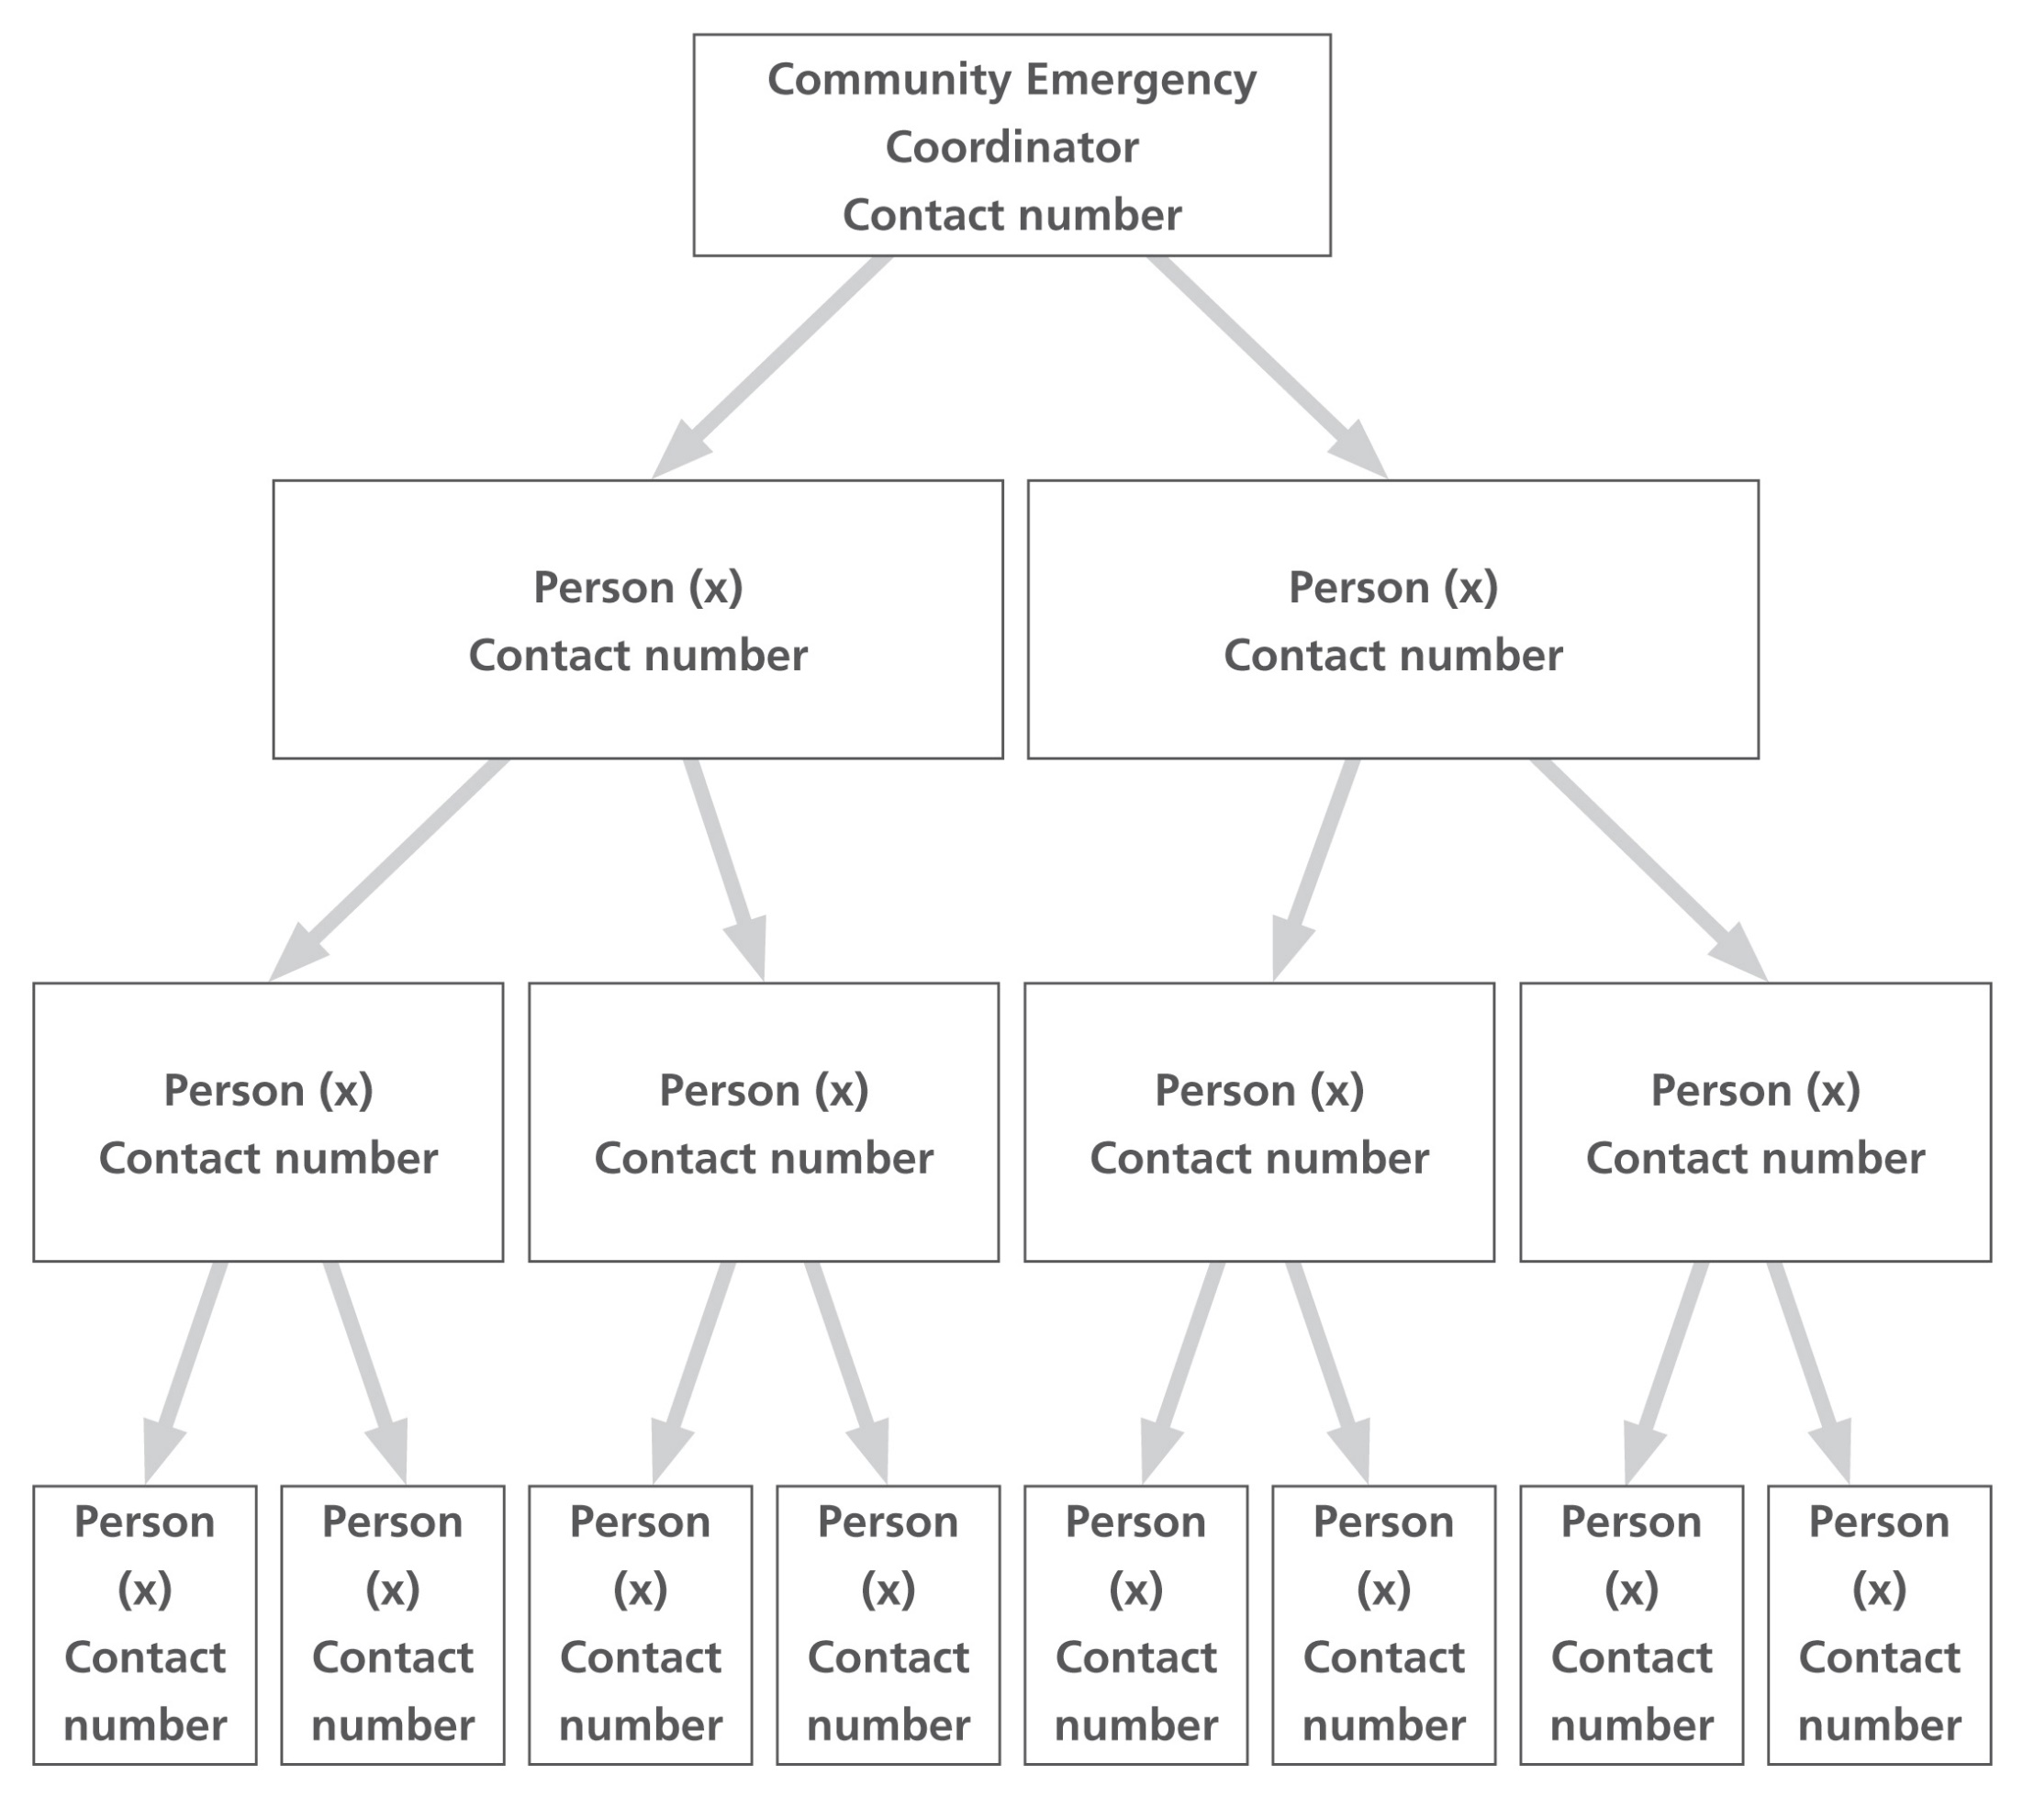

List of community organisations that may be helpful in identifying vulnerable people or communities in an emergency
Organisation | Name and role of contact | Phone number
Anytown Care | Duty contact | 07800 555xxxx

Activation triggers
[Use this space to record details of how your plan will be activated. You should include details of how the plan will be activated as a result of a call from the emergency services, and also how your community will decide to activate the plan yourselves, if the emergency services are unavailable]

- When we get a flood warning

- When PC Rathbone rings the coordinator

First steps in an emergency

[Use this space to add the steps to be followed in when the plan is activated]
 | Instructions | Tick
1 | Call 999 (unless already alerted)
2 | Ensure you are in no immediate danger
3 | Contact the Community Emergency Group and meet to discuss the situation
4
5
6
7
8
9
10

Community Emergency Group first meeting agenda
Date:
Time:
Location:
Attendees:

1. What is the current situation?
Location of the emergency. Is it near:
- A school?
- A vulnerable area?
- A main access route?
- Type of emergency:
- Is there a threat to life?
- Has electricity, gas or water been affected?
Are there any vulnerable people involved?
- Elderly
- Families with children
What resources do we need?
- Food?
- Off-road vehicles?
- Blankets?
- Shelter?

2. Establishing contact with the emergency services

3. How can we support the emergency services?

4. What actions can safely be taken?

5. Who is going to take the lead for the agreed actions?

6. Any other issues?

Actions agreed with emergency responders in the event of an evacuation
[Use this space to record details of the actions you can take to help your local authority if an evacuation is necessary in your community.]

- Help police/local authority with door knocking
- Tell emergency services who might need extra help to leave their home

Alternative arrangements for staying in contact if usual communications have been disrupted

Communication Type | Name of contact | Location
Radio | Anytown RAYNET - John Springston | 22 Larch Drive

