Stratfield Mortimer to Burghfield
Updated layout
Shared Cycleway/Footway
Produced for:
Ridge

Date: March 2023
Stage 1 Road Safety Audit Report
(Feasibility)
07771 557382

trafficmanagementconsultants@hotmail.co.uk

DOCUMENT REGISTER

Project Name: Stratfield Mortimer to Burghfield Cycleway/Footway Feasibility

Report Title: Stage 1 Road Safety Audit.

Date: 4th March 2022

Client: Ridge

Audit Team | Name | Position | Date
Audit Team Leader: | Peter Ronald | Director | 04/03/2023
Audit Team Member: | Lee Turner | Road Safety Auditor | 04/03/2023
Approved By: | Peter Ronald | Director | 04/03/2023

Revision History
Revision | Date | Description | Audit Team Leader | Audit Team Member | Approved
- | 04/03/2023 | Draft | PR | LT | PR
A | 04/03/2023 | Final | PR | LT | PR

Prepared By: Traffic Management Consultants Ltd
Unit 2
71A Hamilton Road
READING
RG1 5RA
07771 557382
trafficmanagementconsultants@hotmail.co.uk

14 Aintree Lane
Liverpool
L10 2JL

Disclaimer
“No part of this report may be copied or reproduced by any means without prior written permission from Traffic Management Consultants. If you have received this report in error, please destroy all copies in your possession or control and notify Traffic Management Consultants.

This report has been prepared for the exclusive use of the commissioning party and unless otherwise agreed in writing by Traffic Management Consultants, no other party may use, make use of, or rely on the contents of the report. If others choose to rely upon this report they do so entirely at their own risk. No liability is accepted by Traffic Management Consultants for any use of this report, other than for the purposes for which it was originally prepared and provided.

Opinions and information provided in the report are based on Traffic Management Consultants using due skill, care, and diligence in the preparation of the same and no explicit warranty is provided as to their accuracy. It should be noted, and it is expressly stated, that no independent verification of any of the documents or information supplied to Traffic Management Consultants has been made.”

Table of Contents
1. Executive Summary 5
2. Introduction 5
3. Risk Assessment 7
4. Historical Summary 7
5. Existing Environment 7
6. Collision Data 8
7. Survey Information 8
8. Audit Assessment 8
9. Nil Response/Comments 19
10. Non-Motorised User Report (NMUs) 20
11. Audit Team Statement 21
12. Appendix A - List of Documents 22
13. Appendix B - Identified Road Safety Audit Matters Location Plans 22
14. Appendix C – Designer, Overseeing Authority and Auditor Response to Stage 1 RSA 25

Executive Summary
1.1 This scheme is promoted by Stratfield Mortimer Parish Council. This Road Safety Audit is supplied under the provisions of the Safety Audit Request dated 23rd February 2023.

Introduction
2.1 This report results from a Stage 1 Road Safety Audit carried out on proposals to provide a combined Footway /cycle path on land between Stratfield Mortimer and Burghfield adjacent to Reading Road, and new Parallel Crossing at the junction of Reading Road /Goring Lane/Padworth Road junction at the northern end of the new path. The new path mostly follows an existing tack through woodland and an existing tarmac path to the south adjacent to College Piece.

2.2 Audit Team Membership
The Audit Team comprised the following individuals:

Peter Ronald I. Eng., AMICE, MCIHT, MSoRSA, (HE - RSA Cert of Comp).
(Audit Team Leader)

Lee Turner MCIHT.
(Audit Team Member)

2.3 Audit Site Visit
A site visit was carried out on Tuesday 28th February 2023 by the Audit Team between 1.00pm and 2.30pm. The weather conditions were dry & overcast. The road surface was dry. Traffic flows were light and limited pedestrian and minimal cycle movements were observed. Vehicle speeds were perceived to be within the posted derestricted speed limit along Reading Road.
The Audit also comprised an examination of the drawing provided by Ridge and any additional support documents completed by the Audit Team as listed in Appendix A. All safety issues are with reference to the feasibility design details shown on the drawings.

2.4 Strategic Decisions
The Audit Team has not been advised of any Strategic Decisions made by the local Highway Authority or by the local Planning Authority.

2.5 Audit Brief
The Audit Team were not provided with an Audit Brief by the Local Authority.

2.6 Terms of Reference
The terms of reference of the audit are based on “Guidelines For the Safety Audit of Highway Schemes” published by the Institution of Highways and Transportation, other guidance references are the Traffic Signs Regulations and General Directions 2016, and GG 119 Design Manual for Roads and Bridges.
The Audit Team has examined and reported only on the road safety implications of the scheme and has not verified the compliance of the designs to any other criteria. However, to clearly explain a safety problem or the recommendation to resolve a problem the Audit Team may, on occasion, have referred to a design standard or other guidance documents.

2.7 Audit Recommendations
Recommendations included within this report should not be regarded as being prescriptive design solutions to the problems identified. They are only to indicate a proportionate and viable means of eliminating or mitigating the identified road safety audit matters, and in no way imply that a formal design process has been undertaken.
There may be alternative measures of addressing a problem which would be equally acceptable or superior in achieving the desired degree of mitigation and these should be considered by the designer when responding to this report.

2.8 Scope of Road Safety Audits
Road Safety Audit shall only be concerned with Road Safety Matters i.e., an element of the existing road environment or proposed road environment that could potentially contribute to a road traffic collision or features that could present a risk of injuries to road users.

Road Safety Audit is not a technical check that the design conforms to standards and/or best practice guidance.

Road Safety Audit is not a check that the scheme has been constructed in accordance with the design.

Road Safety Audit does not consider structural safety.

Road Safety Audit does not cover health and safety issues concerning road workers during the construction phase but may cover the future maintenance and operation of the road.

Road safety matters resulting from the operation of facilities for highway maintenance that affect road users shall be included in the scope of Road Safety Audit.

The needs of all road users shall be assessed when undertaking Road Safety Audits.

Risk Assessment
3.1 Each of the Auditors’ responses is classified as either a ‘Problem’ or a ‘Nil Response/Comment’. Items classified as a 'Problem' denote matters likely to result in significant road safety hazards. Items marked as ‘Nil Response/Comment’ are less serious but worthy of consideration by the Designer and/or by the Overseeing Organisation.

3.2 Although all the problems identified are of sufficient importance to require action, the table below shows their relative urgency based on the risk perceived by the Safety Auditors. The level of risk assigned to each problem is largely subjective and is only intended as a guide to assist the client in determining the priority of the road safety matters raised.

Severity / Risk Level | Probability
 | Frequent | Probable | Occasional | Remote | Improbable
Catastrophic | ****Problem****  (Urgent)
Critical |  | ***Problem***  (High Risk)
Major |  |  | **Problem**  (Medium Risk)
Minor |  |  |  | *Problem*  (Low Risk)
Negligible |  |  |  |  | Comment

Historical Summary
4.1 Unknown.

Existing Environment
  - Reading Road is a single carriageway rural local distributor road that links through from Mortimer to Burghfield running in a south /north direction with grass verges on each side fronting woodland. It has a derestricted speed limit and does not have a system of street lighting. It is also a bus route. There is limited development along the route

  - There is a short length of Reading Road that has a steep gradient and hidden dip just north of Longmoor Lane near Five Oaken Cottage

The proposed path follows an existing tarmac path adjacent to the College Piece residential development.

Collision Data
  - The Audit Team have not been provided with any recorded injury collision data as part of this road safety audit. However, interrogation of www.crashmap.co.uk indicates that there was two slight personal injury collisions on the section of Reading Road that is the subject of this audit during the 2017 - 2021 five-year period. One occurred south of Longmoor Lane in March 2021 and involved two vehicles the second was at the Reading Road /Padworth Road junction in April 2020 and involved two vehicles.

Survey Information
7.1 None provided.

Audit Assessment
8.1 The table below summarises the findings from this audit which are described in detail within the following pages.
Identified locations of Road Safety Audit Matters are indicated on drawings within Appendix B to the rear of this report.

No. | Item | Comments | Notes
A1 | General
A1.1 | Departures from Standards
A1.2 | Cross-sections
A1.3 | Cross-sectional Variation
A1.4 | Drainage |  | Not detailed
A1.5 | Landscaping | Problem | (8.1) Vegetation obstructs visibility of new crossing for vehicles approaching from Padworth Road
A1.6 | Public Utilities/Services Apparatus
A1.7 | Lay-bys
A1.8 | Access | Problem | (8.2) Proposed refuge island restricts existing vehicle access to number 2
A1.9 | Emergency Vehicles
A1.10 | Future Widening
A1.11 | Adjacent Development
A1.12 | Basic Design Principles
A2 | Local Alignment
A2.1 | Visibility
A2.2 | New/Existing Road Interface
A2.3 | Vertical Alignment
A3 | Junctions
A3.1 | Layout
A3.2 | Visibility | Problem | (8.3) Reduced visibility at the Longmoor Lane junction at crossing point
A4 | Non-Motorised User Provision
A4.1 | Adjacent land
A4.2 | Pedestrian/cycle routes provided | Problems | (8.4) Additional footways required at the northern junction with Reading Road / Goring Lane to facilitate pedestrian access to the proposed path from Goring Lane and the eastern side of Reading Road  (8.5) Additional measures will be required at the southern junction with Victoria Road / St Catherine’s Hill to facilitate access to the proposed path  (8.6) Upgraded paths will be required to facilitate cycle access from the adjacent College Piece development along the exiting pedestrian paths  (8.7) Cycle crossing width needs to be increased to 3m as two way  (8.8) Existing footway on western side of new cycle crossing will need to be changed to shared use.
A4.3 | Facilities adequate
A4.4 | Separation from carriageway
A4.5 | Special requirements elderly/young infirm
A4.6 | Tactile paving/guardrails | Problem | (8.9) Incorrect tactile paving layout detailed at controlled crossing
A4.7 | Junctions
A4.8 | Routes clear of obstruction | Problems | (8.10) Stile will need to be removed north of College Piece at start of woodland path as this will obstruct cycles access  (8.11) Vehicle observed parked infront of Five Oaken Cottage causing obstruction
A4.9 | Equestrians
A5 | Road Signs, Carriageway Markings And Lighting
A5.1 | Signs
A5.2 | Lighting | Comment | (9.1) Lighting improvements may need to be improved at new Parallel Crossing
A5.3 | Poles and Columns
A5.4 | Road Markings

8.1 *Problem* (Item A1.5)
Location: | Reading Road /Padworth Road junction
Summary: | Vegetation obstructs visibility of new crossing for vehicles approaching from Padworth Road
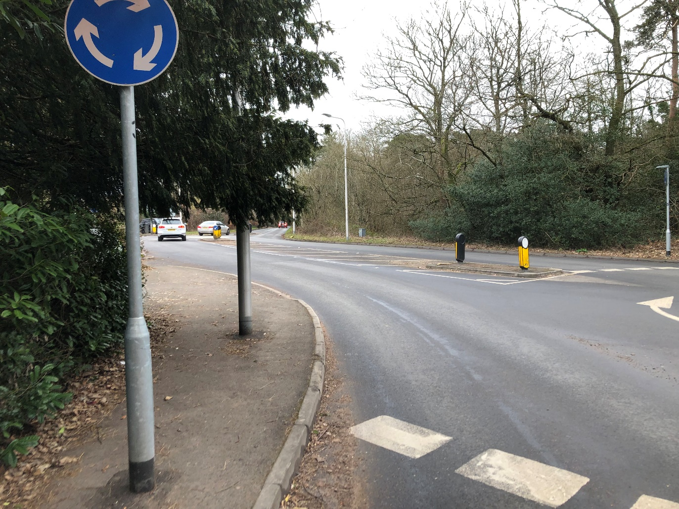
A new controlled crossing is detailed . There is vegetation that obstructs the visibility of the new crossing for vehicles approaching from Padworth Road . This vegetation will need to be cut back to ensure the crossing can be seen from Padworth Road.

TYPE OF CONFLICT/COLLISION
Risk of collisions on crossing due to reduced visibility
RECOMMENDATION
Cut back vegetation as required to improve visibility

8.2 *Problem* (Item A1.8)
Location: | Reading Road. Vehicle access to number 2
Summary: | New pedestrian crossing refuge island restricts vehicle access to property
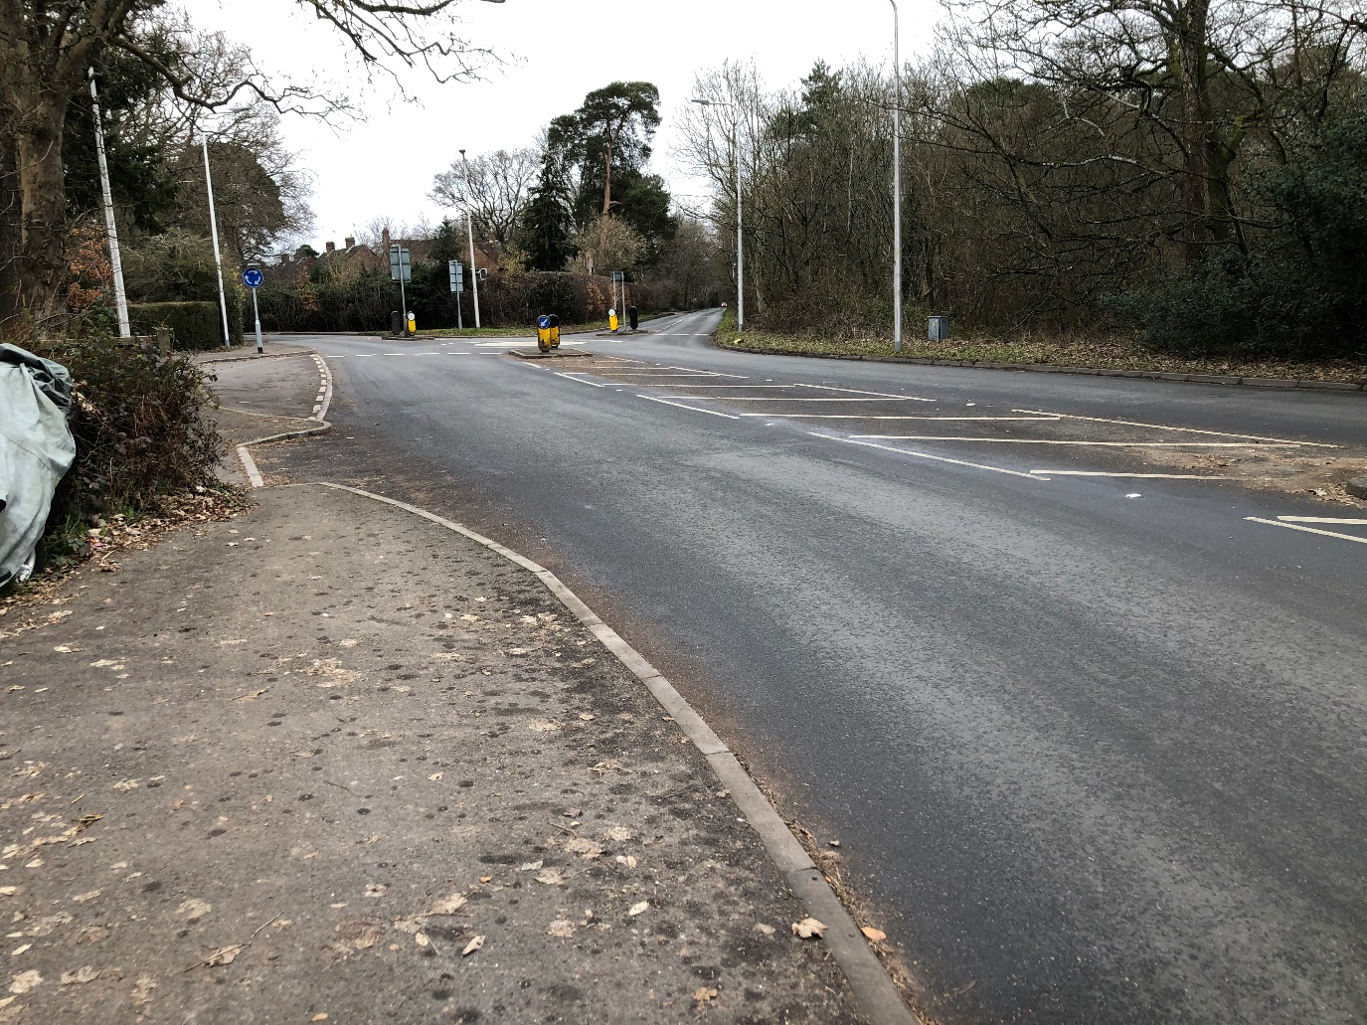
A new controlled crossing is detailed with central pedestrian refuge island. This island appears to restrict the vehicle access to number 2. Carry out vehicle swept path analysis to confirm that vehicle access is maintained to the property.

TYPE OF CONFLICT/COLLISION
Risk of vehicles unable to access vehicle access to number 2
RECOMMENDATION
Carry out vehicle swept path analysis to confirm that vehicle access is maintained to the property and amend design if necessary

8.3 **Problem** (Item A3.2)
Location: | Reading Road / Longmoor Lane
Summary: | Reduced visibility at pedestrian/cycle crossing point at junction of Reading Road /Longmoor Lane
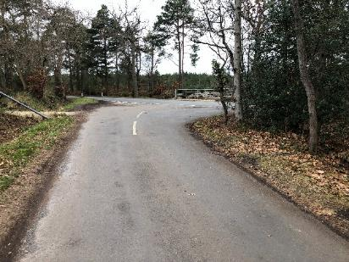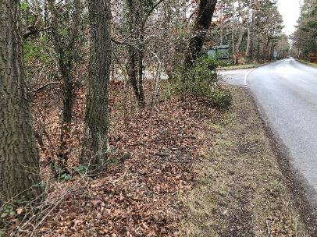

The new path crosses over the Longmoor Lane junction. There is reduced visibility of oncoming /turning vehicles at the junction this is resulting in potential collisions with pedestrians and cycles crossing the side road . Ensure that adequate visibility is achievable at the crossing point

TYPE OF CONFLICT/COLLISION
Collisions at junction due to reduced visibility
RECOMMENDATION
Ensure that adequate visibility is provided at the crossing point

8.4 **Problem** (Item A4.2)
Location: | Reading Road /Goring Lane junction
Summary: | Additional lengths of path and pedestrian crossing point required at Reading Road/Goring Lane junction
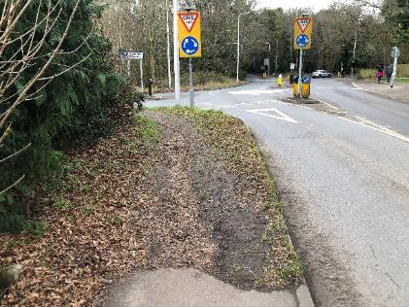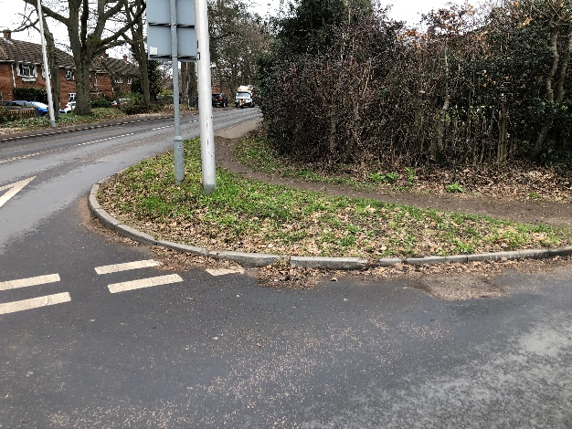
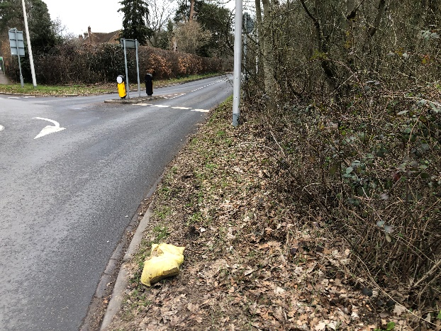
The new path will introduce additional pedestrian /cycle crossing movements at the Reading Road /Goring Lane junction where there is an existing established worn path with people wanting to access the new path . Additional facilities will be required at the junction to enable pedestrians and cyclists to negotiate around the junction to access and exit from the new path

TYPE OF CONFLICT/COLLISION
Collisions due to inadequate pedestrian / cycle paths and crossing points at junction
RECOMMENDATION
Provide additional lengths of footway/cycle paths with crossing points at junction

8.5 **Problem** (Item A3.2)
Location: | Victoria Road / St Catherine’s Hill junction and along Victoria Road at existing bus stop
Summary: | Additional pedestrian /cycle crossing facilities required at Victoria Road junction and along Victoria Road to provide access to new path
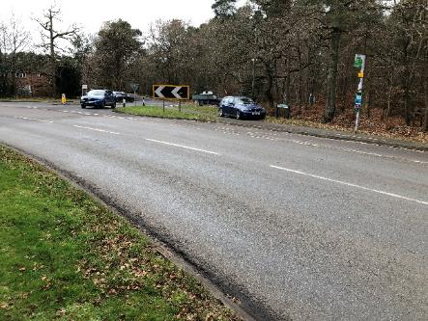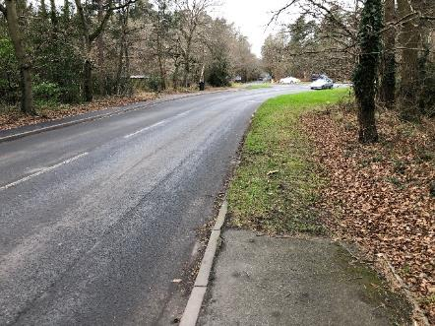

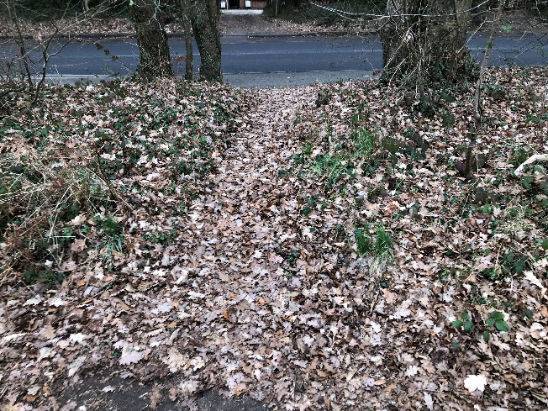

A new pedestrian/cycle path is detailed set back to the northeast of the existing junction with Victoria Road and St Catherine’s Hill . There are no facilities proposed to enable pedestrians and cyclists to join the new path from the adjacent junction or to cross over Victoria Road . Provide new paths and pedestrian crossing facilities at the junction and along Victoria Road to enable pedestrians and cyclists to access the new path

TYPE OF CONFLICT/COLLISION
Collisions due to inadequate pedestrian / cycle paths and crossing points
RECOMMENDATION
Provide additional pedestrian crossing facilities at junction and along Victoria Road

8.6 *Problem* (Item A4.2)
Location: | Paths connecting College Piece to new cycle path
Summary: | Existing pedestrian paths need to be upgraded to facilitate cycle access from College Piece to the new shared use path
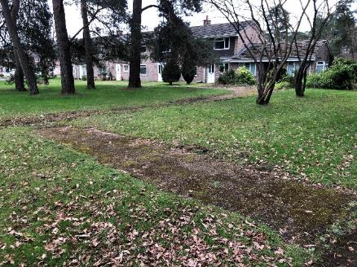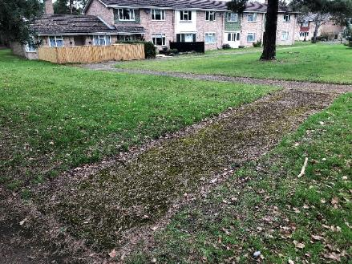

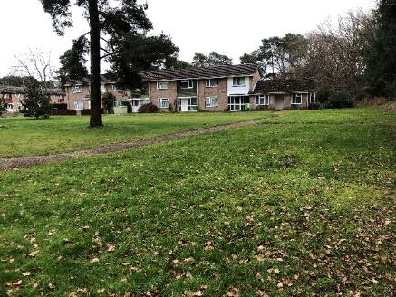

There are existing pedestrian paths from College Piece to the new shared use path. Cyclists will use these paths illegally to access the new shared use facility. Upgrade exiting paths to facilitate safe cycle access to the new shared use path

TYPE OF CONFLICT/COLLISION
Cyclists in collisions with pedestrians on unsuitable paths
RECOMMENDATION
Upgrade existing paths to be shared use

8.7 *Problem* (Item A4.2)
Location: | Reading Road / Goring Lane. Parallel Crossing
Summary: | Cycle crossing width on parallel crossing needs to be increased to 3m as two way
There is a two way cycle crossing detailed at the new parallel crossing that is only 2m wide . Current guidance recommends 3m minimum width for such two way cycle crossings so it can be used by two way cycles safely. Amend design to increase width of cycle crossing to 3m if possible

TYPE OF CONFLICT/COLLISION
Risk of collisions between two way cycles crossing road
RECOMMENDATION
Amend design to increase width of two way cycle crossing to 3m if possible

8.8 *Problem* (Item A4.2)
Location: | Reading Road . Footway on western side of new crossing
Summary: | Existing footway needs to be changed to be shared use to link up with proposed parallel crossing
There is a new parallel crossing detailed that allows cycles to cross over the road from the new shared use path. The footway on the western side of the new crossing needs to be changed to shared use to allow cycles to use the path legally

TYPE OF CONFLICT/COLLISION
Risk of collisions between pedestrians and cycles using footway illegally
RECOMMENDATION
Change footway on western side of new parallel crossing to be shared use

8.9 *Problem* (Item A4.6)
Location: | Reading Road / Goring Road. Eastern side of new controlled crossing
Summary: | Incorrect tactile paving layout detailed at controlled crossing
There is a new parallel crossing detailed with incorrect tactile paving layout on the easern side of the crossing . This will confuse visually impaired pedestrians waiting to cross over the road. Amed tactile paving layout design.
TYPE OF CONFLICT/COLLISION
Risk of confusion for visually impaired pedestrians crossing road due to incorrect tactile paving
RECOMMENDATION
Amend tactile paving layout design.

8.10*Problem* (Item A4.8)
Location: | New path along Reading Road north of College Piece
Summary: | Existing stile will need to be removed to facilitate cycle access to new path
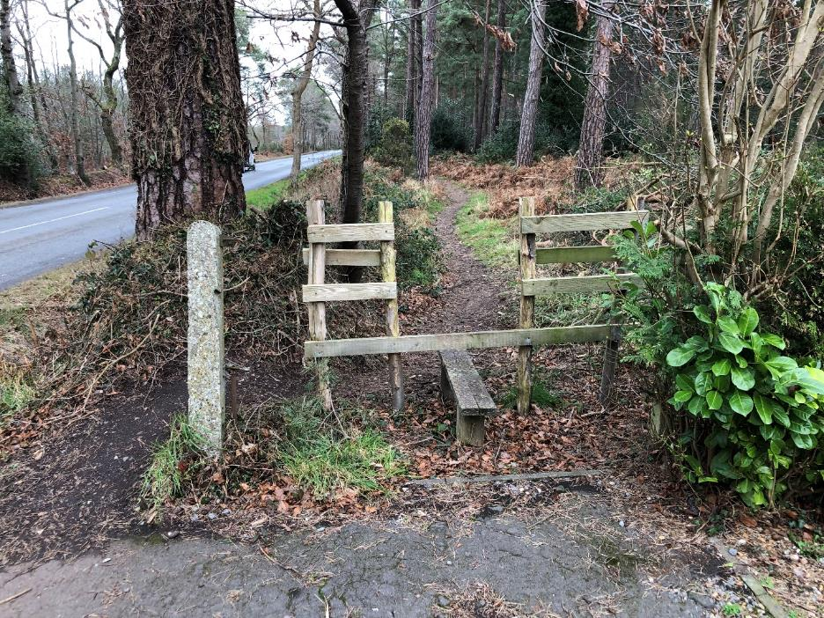
There is an existing stile on the route of the new path. This will obstruct cycle access and requires removal

TYPE OF CONFLICT/COLLISION
Cycles unable to use new path
RECOMMENDATION
Remove stile from new path

8.11 *Problem* (Item A4.8)
Location: | Reading Road .Path infront of Five Oaken Cottage
Summary: | Parked vehicle observed inline of new path outside Five Oaken Cottage
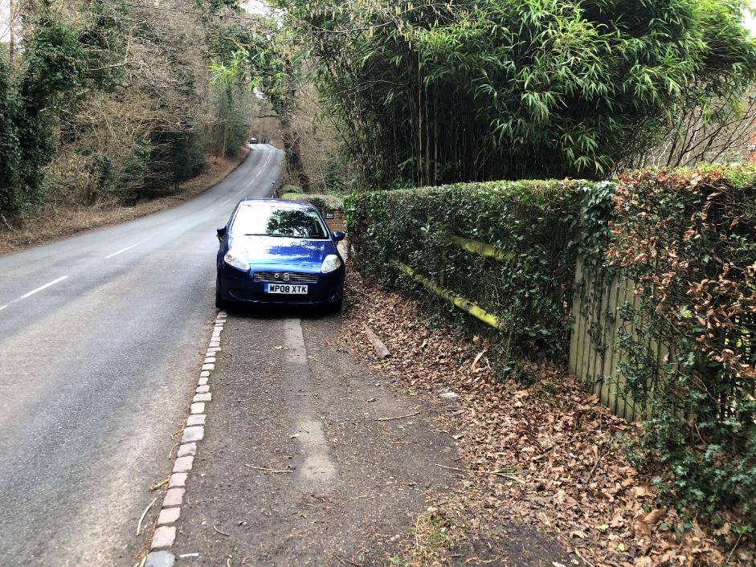

A new shared use path is detailed along the eastern side of Reading Road passing infront of Five Oaken Cottage. There was a parked vehicle observed that will obstruct the new path. Monitor parking and introduce additional parking restrictions if required or proceed with optional route as proposed
TYPE OF CONFLICT/COLLISION
Pedestrian / cyclist conflict with parked vehicles
RECOMMENDATION
Monitor parking to see if additional measures required or proceed with optional route

Nil Response/Comments

  - Lighting may need to be improved at new controlled crossing

Non-Motorised User Report (NMUs)
  - The scheme provides improved pedestrian / cycle facilities along Reading Road between Mortimer and Burghfield to encourage more active travel. This report has identified road safety problems affecting pedestrians and cyclists that should be considered.

Audit Team Statement
I certify that we have examined the drawings listed within Appendix A and that the site has been inspected. The examination has been carried out with the sole purpose of identifying road safety matters that can be addressed to improve the safety of the scheme.
The problems identified have been noted in the report together with associated safety improvement suggestions that we recommend should be studied for implementation.
I can confirm that we have not been involved with the scheme design.

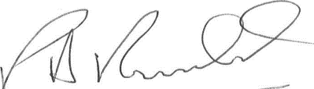
Peter Ronald 4th March 2023
(Audit Team Leader)

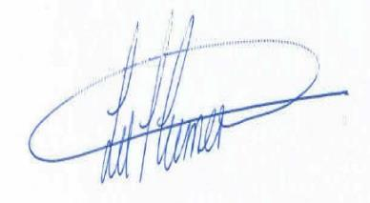
Lee Turner 4th March 2023
(Audit Team Member)

Appendix A - List of Documents

Drawings
Title Drg. No. Revision
General Arrangement 5014549-RDG-XX-XX-DR-C-010 P03
Northern crossing general arrangement 5014549-RDG-XX-XX-DR-C-011 P01

Appendix B - Identified Road Safety Audit Matters Location Plans

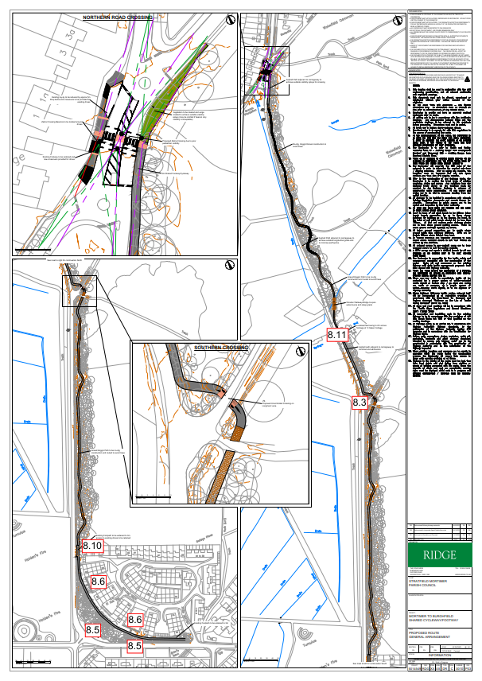

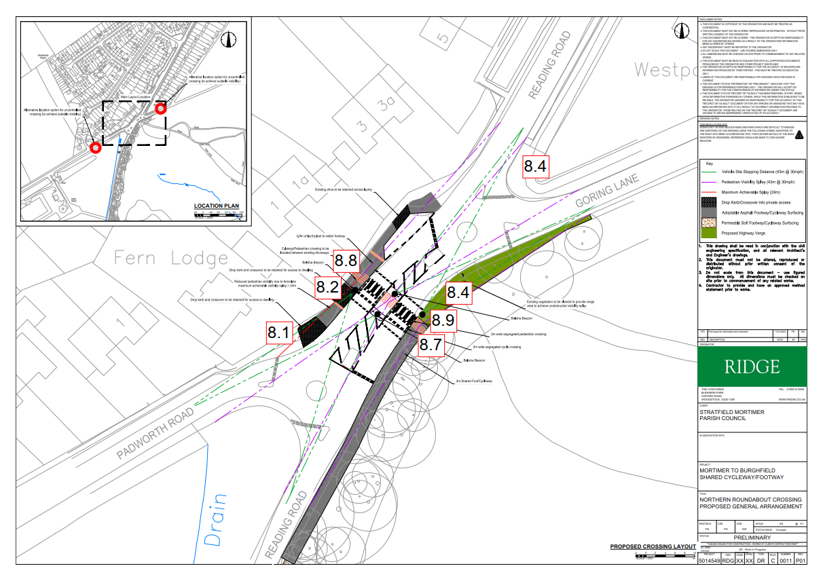

Appendix C – Designer/Overseeing Authority and Auditor Response to Stage 1 Road Safety Audit

Stage 1 Road Safety Audit
DESIGNER’S ROAD SAFETY AUDIT RESPONSE
Scheme Name: Stratifield Mortimer to Burghfield Cycleway Facility
The issues categorised in this road safety audit as ‘Problem’ matters are those causing serious concern and are summarised below. The purpose of this form is for the scheme Designer or Overseeing Organisation to respond to the ‘Problem’ matters. Responses should be returned to Traffic Management Consultants. ‘Comments’ in this report are made for the benefit of the Designer and are not referred to below.
RSA Matter | Summary of RSA Problem | Designer’s Response | Overseeing Authority Response
8.1 | Vegetation obstructs visibility of new crossing for vehicles approaching from Padworth Road | Vegetation will be trimmed back as part of crossing/widening works in this area.
8.2 | New pedestrian crossing refuge island restricts vehicle access to property | Vehicle access for southbound vehicles accessing property will be impacted, vehicles will be able to U-turn at roundabout
8.3 | Reduced visibility at pedestrian/cycle crossing point at junction of Reading Road /Longmoor Lane | Vegetation will be trimmed back, vehicles turning into Longmoor Lane will be at reduced speed.
8.4 | Additional lengths of path and pedestrian crossing point required at Reading Road/Goring Lane junction | The proposals provide a formal crossing to avoid the need for this type of informal path and crossing.
8.5 | Additional pedestrian /cycle crossing facilities required at Victoria Road junction and along Victoria Road to provide access to new path | The scheme is to provide a link along Reading Road. The limit of works must be realistic to ensure financial viability of the scheme.
8.6 | Existing pedestrian paths need to be upgraded to facilitate cycle access from College Piece to the new shared use path | Similar to 8.5, the extent of works must respect the main objective and remain financially viable.
8.7 | Cycle crossing width on parallel crossing needs to be increased to 3m as two way | The overall crossing width is 4m. The route is expected to be low usage so regular two way traffic is unlikely.
8.8 | Existing footway needs to be changed to be shared use to link up with proposed parallel crossing | It is proposed to end the shared route here.
8.9 | Incorrect tactile paving layout detailed at controlled crossing | Amended
8.10 | Existing stile will need to be removed to facilitate cycle access to new path | This will be removed
8.11 | Parked vehicle observed inline of new path outside Five Oaken Cottage | Noted. The introduction of a full height kerb should also discourage this type of parking.

AUDIT TEAM RESPONSE to designers comments

8.1
8.2
8.3
8.4
8.5
8.6
8.7
8.8
8.9
8.10
8.11

